General tips for the Task below.
Task Title
AWS- Key Management Services (KMS) and Secrets Manager (SM)
Objective
Worked on pre-requisite, as I performed R&D on the AWS-Key Management Services (KMS) and Secrets Manager (SM) posted in DevOps group in slack as a requirement and task to work on Use cases, architecture flow and execution steps
Prerequisites
List all requirements before starting:
- AWS-Key Management Services
- AWS- Secrets Manager
Issues Faced: Briefly mention issues and how you fixed them. Posted below in the last.
Conclusion
Conclusion has been provided for every task at the end.

AWS- Key Management Services

What is Key Management Services?
Ans. AWS Key Management Service (KMS) is a fully managed security service that helps you create, control, and manage encryption keys.
It helps protect data by encrypting and decrypting it securely.
What is encryption and Decryption?
Encryption:
Encryption is the process of converting readable data (plaintext) into unreadable data (ciphertext) so that unauthorized people cannot understand it.
Even if someone steals the encrypted data, they cannot read it without the key.
In Encryption, we have 2 keys, they are;
- Symmetric key- Same key is used to encrypt and decrypt the data.
- Asymmetric key- Different keys are used to encrypt and decrypt the data. The keys are called public key and Private key.
Decryption:
Decryption is the reverse process of encryption.
- It converts ciphertext back into plaintext
- Requires the correct key
Without the key ❌ → data is useless.
Overview of AWS KMS
Centralized Key Management
AWS KMS allows users to manage encryption keys centrally, simplifying the use of cryptographic keys in various applications and services.
Key Creation and Management
Users can easily create, import, rotate, disable, and delete encryption keys with KMS.
Integration with AWS Services
KMS integrates seamlessly with AWS services like S3, EC2, RDS, and Lambda.

🗝️ What is a Key?
A key is a secret value used in encryption and decryption.
Real-Life Analogy 🔑
- Data = Valuable items
- Encryption = Locking
- Key = Physical key
- Decryption = Unlocking
No key → No access.

Why This Is Powerful
✔ Very fast
✔ Highly secure
✔ Keys never leave AWS KMS
✔ Scales easily

🔐 Example with AWS Services
🔹 Amazon S3 (SSE-KMS)
- You upload a file
- S3 asks AWS KMS for a data key
- File is encrypted automatically
- Only users with KMS permission can download & decrypt
Uses:
- Amazon S3
- AWS KMS

Use Cases:
- Encrypt objects in Amazon S3 (SSE-KMS)
- Encrypt volumes & snapshots in Amazon EBS
- Encrypt databases in Amazon RDS
- Encrypt data warehouses like Amazon Redshift
- Encrypt data stored in S3, EBS, RDS
- Encrypt application data
- Secure sensitive information
- Meet security and compliance requirements
- Centralized key management
✅ Protects data even if storage is compromised

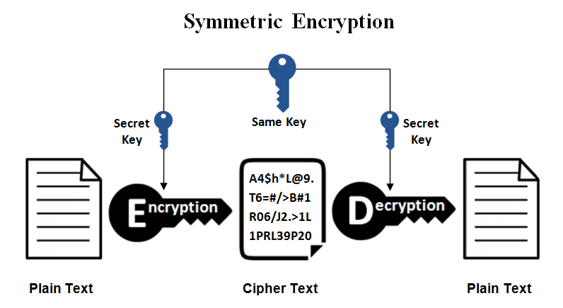

Use case scenario:
Task 1- Encrypt S3 bucket with AWS KMS key.
Objective:
The objective of this task is to create a S3 bucket and encrypt few files with AWS KMS and store the encrypted files and provide access to few users.
Prerequisites:
- AWS KMS
- AWS S3
Step by step Implementation:
Step 1: Navigate to AWS KMS and create a key.
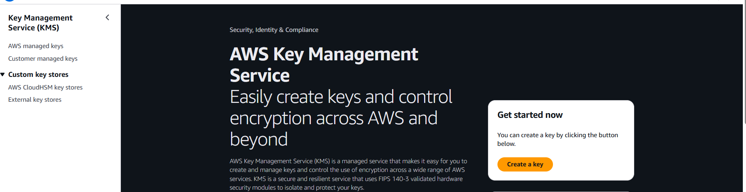
- Key type- Symmetric
- Key usage- Encrypt and decrypt
- Region- Single-region
- Next
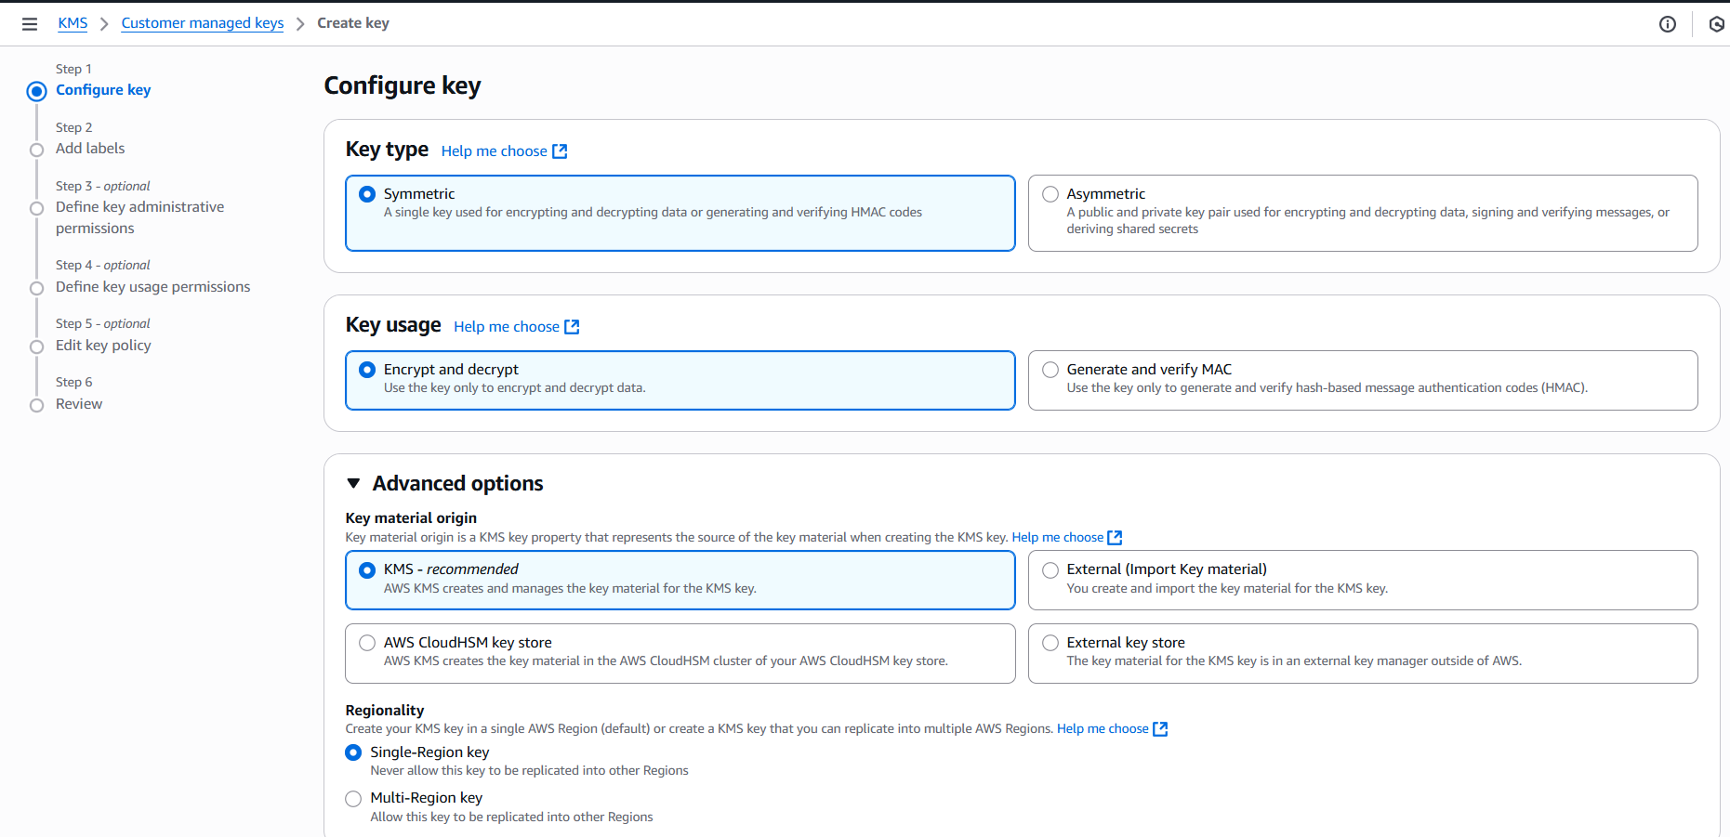

Step 2: Alias- My-S3-key
- Next
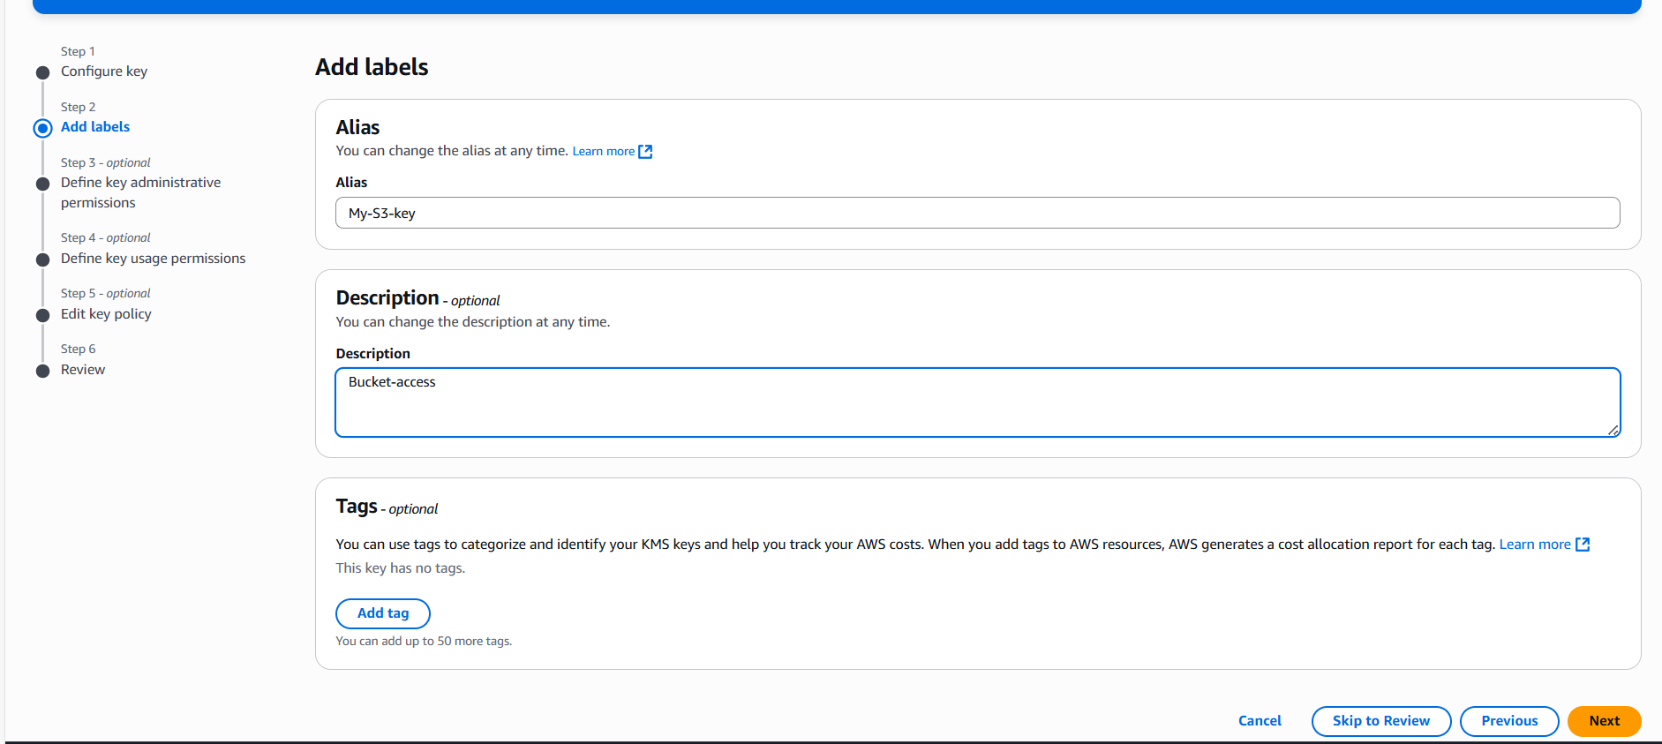
Step 3: Select users who can manage the key (enable/disable, rotate, delete).
- Devops
- Myuser
The above users we created in AWS-IAM
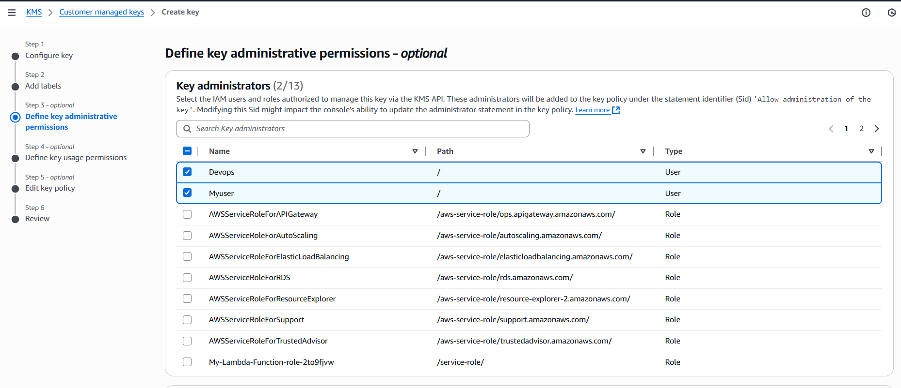

Step 4: Select users who can use the key for encryption and decryption.
- Devops
- Myuser

The above users can encrypt and decrypt
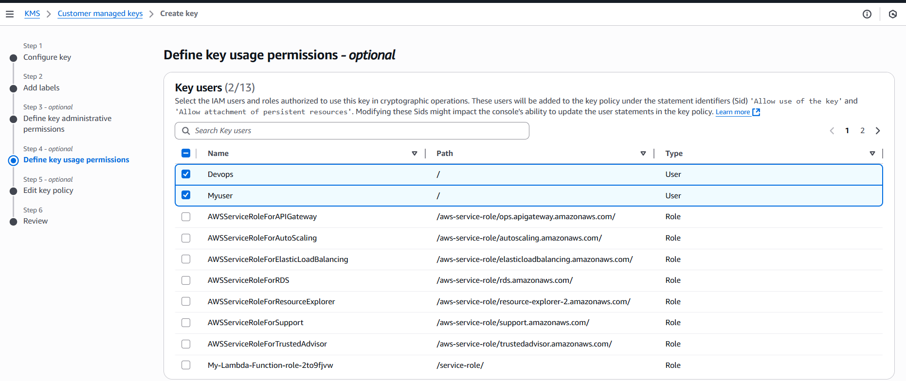

Step 5: This is the policy that will allow us to encrypt and decrypt and who can perform this action in any aws services.
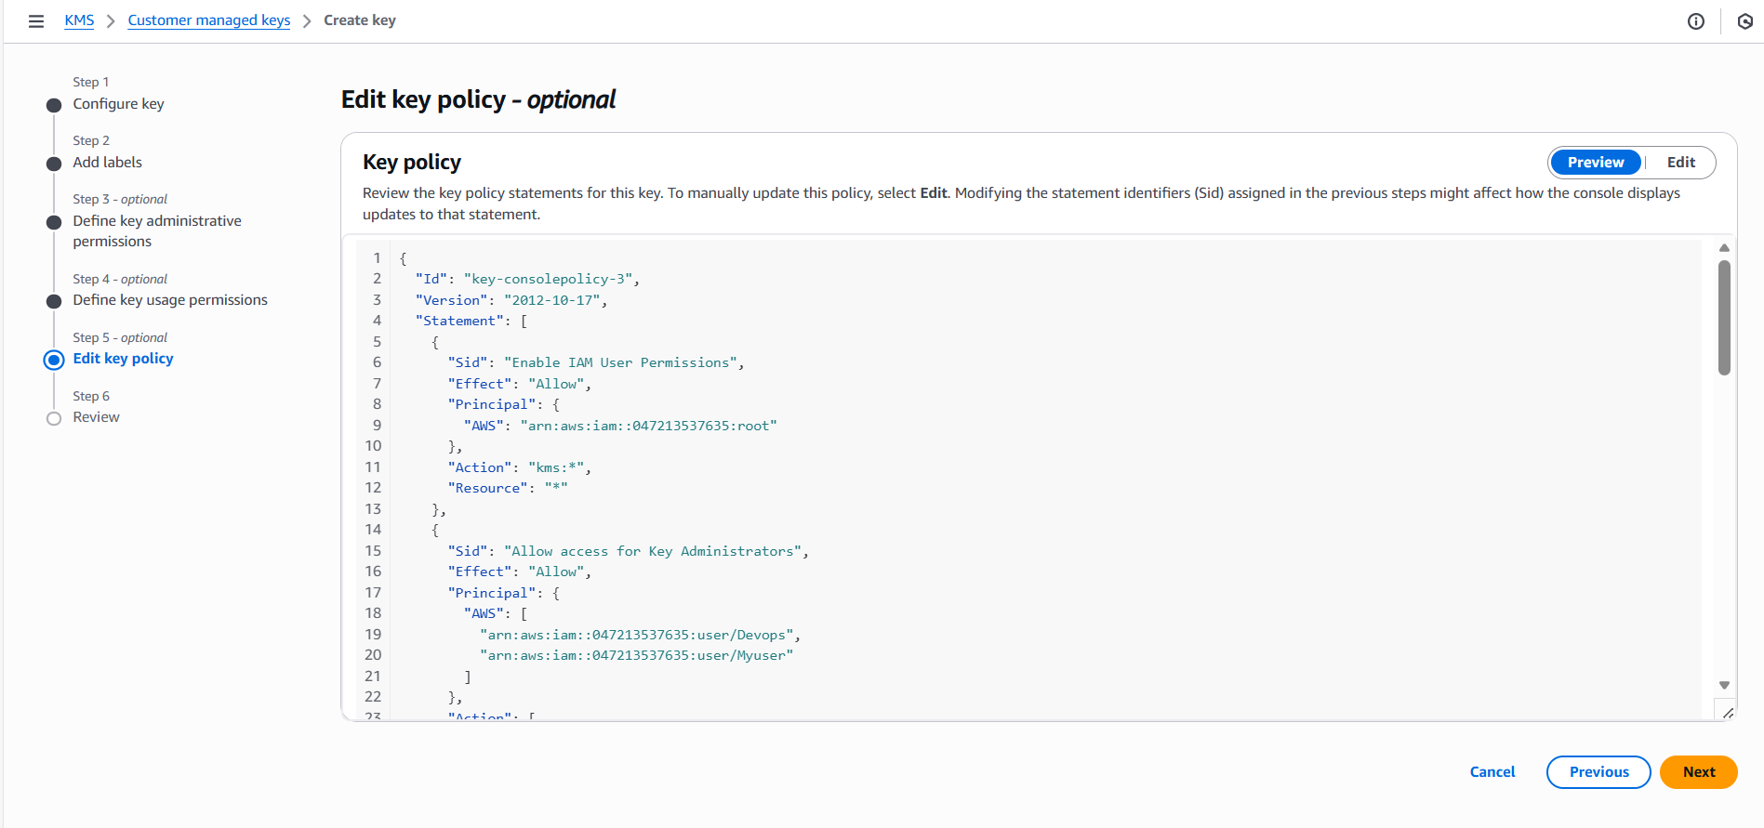

Step 6: Review the final steps and create the key.
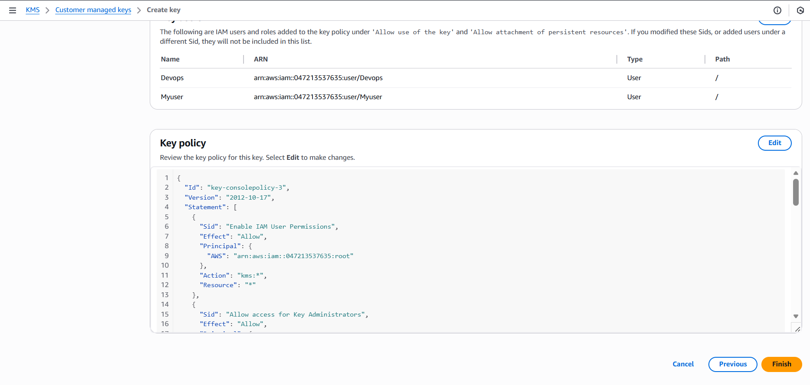

Step 7: AWS KMS Key successfully created.
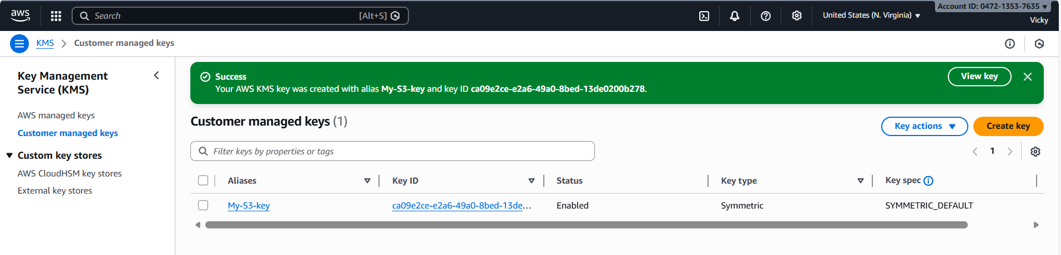

KMS key created successfully
Alias: my-S3-key
Status: Enabled
Key type: Symmetric
Key spec: SYMMETRIC_DEFAULT

This key is now available for:
- S3 encryption
- EBS encryption
- Secrets Manager
- Other AWS services

Step 8: Let’s create a new S3 bucket
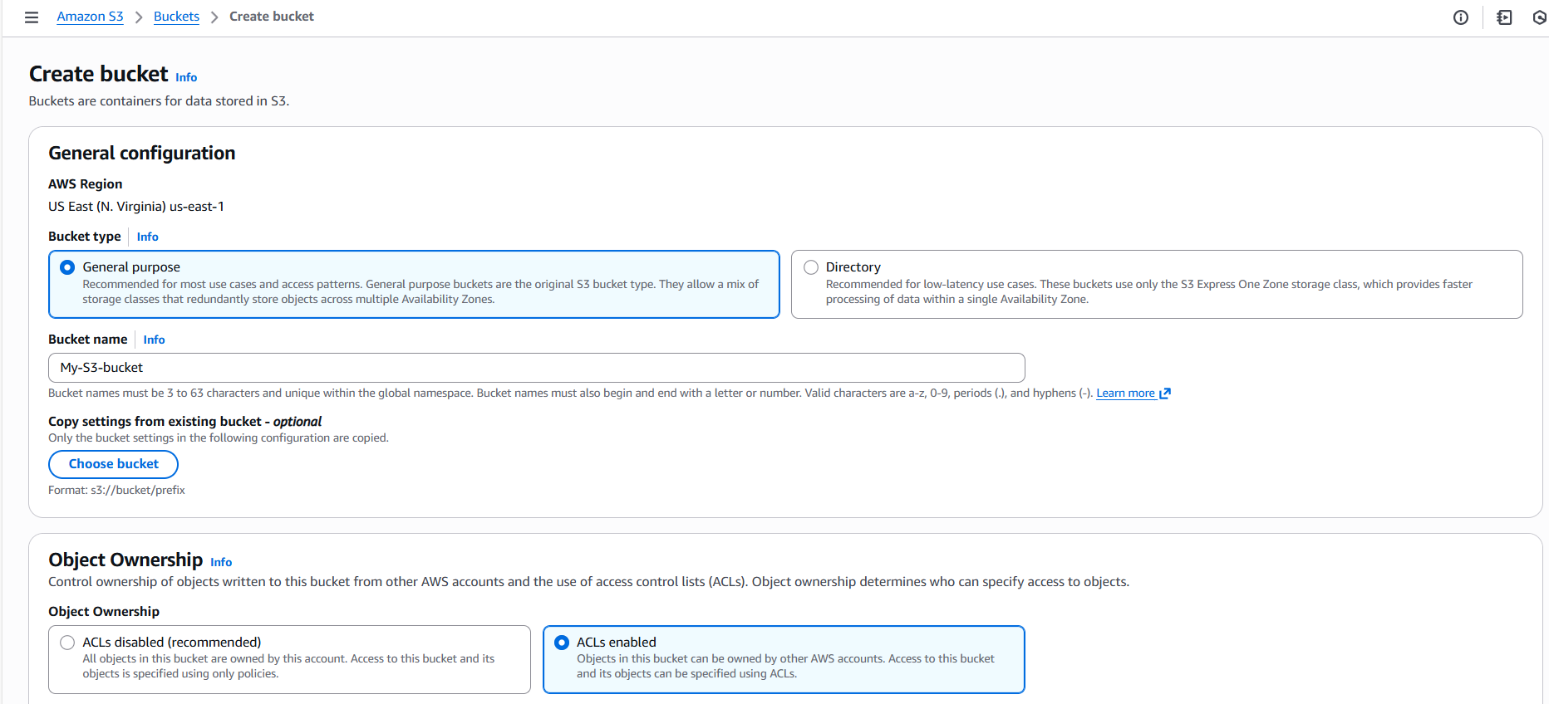

Step 9: Select SSE-KMS in Encryption type and choose the key from dropdown option.
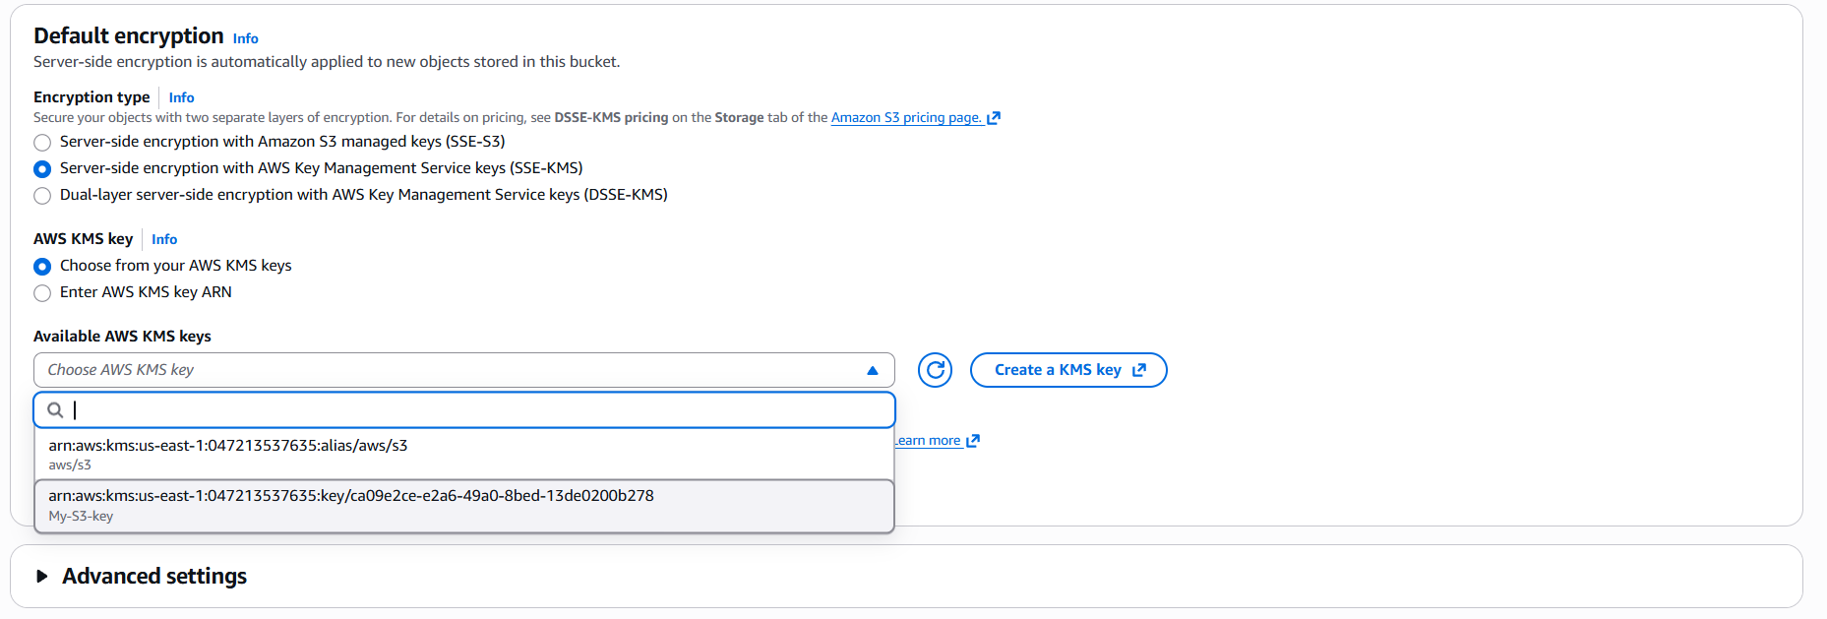

Step 10: Bucket created successfully.
Success- Now the S3 bucket is encrypted and only the authorised users can decrypt and use the bucket.
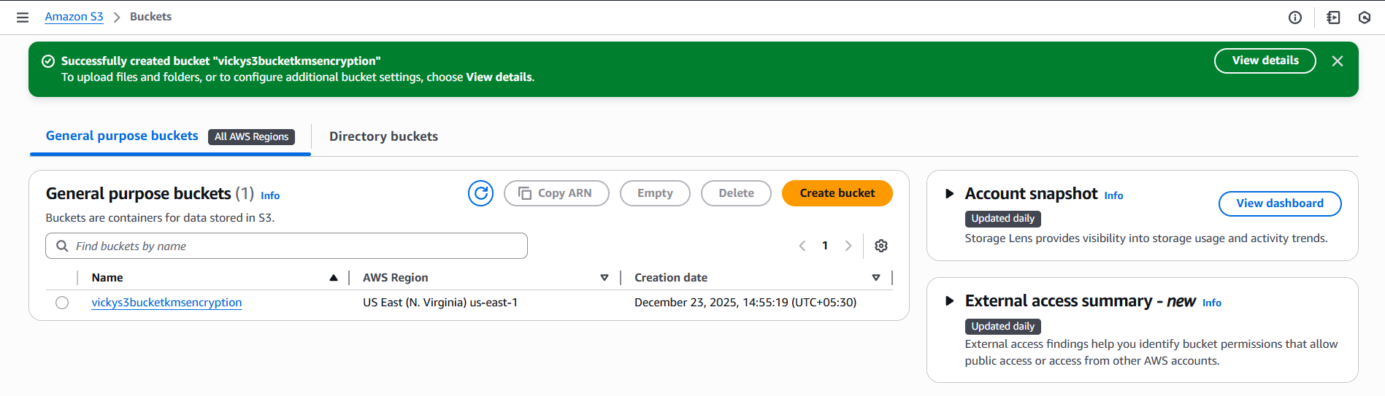
Secrets Manager

What is Secrets Manager?
AWS Secrets Manager is a fully managed AWS service used to securely store, retrieve, rotate, and manage sensitive information.

Sensitive Information such as:
- Passwords
- API Keys
- Database credentials

❓ What Problem Does Secrets Manager Solve?
Without Secrets Manager:
- Passwords stored in code ❌
- Secrets in GitHub ❌
- Manual rotation ❌
- High security risk ❌
With Secrets Manager:
- Encrypted storage ✅
- Fine-grained access control ✅
- Automatic rotation ✅
- Audit logging ✅

Use Case:
An application needs a database username and password. Instead of storing it in code, we store it securely in Secrets Manager.

AWS Secrets Manager Architect Flow:
Application

IAM Role

Secrets Manager

AWS KMS

Use case Scenario

Task- Store and Retrieve Database credentials using AWS Secrets Manager
Objective:
The objective of this task is to store and retrieve my database credentials using Secrets Manager in AWS services.
Prerequisites:
- AWS KMS
- AWS Secrets Manager
Step by step Implementation:
Step 1: Navigate to AWS secrets Manager and create a new secret
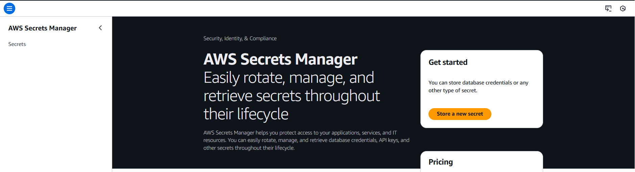
Step 2: Choose Secret type as “other type of secret”
Key/Value pairs- Choose your user and password.
User- Root
Password (Value)- root@123456

Select Encryption Key Under Encryption key:
Choose aws/secretsmanager (Default AWS managed KMS key)
This ensures the secret is encrypted using AWS KMS.
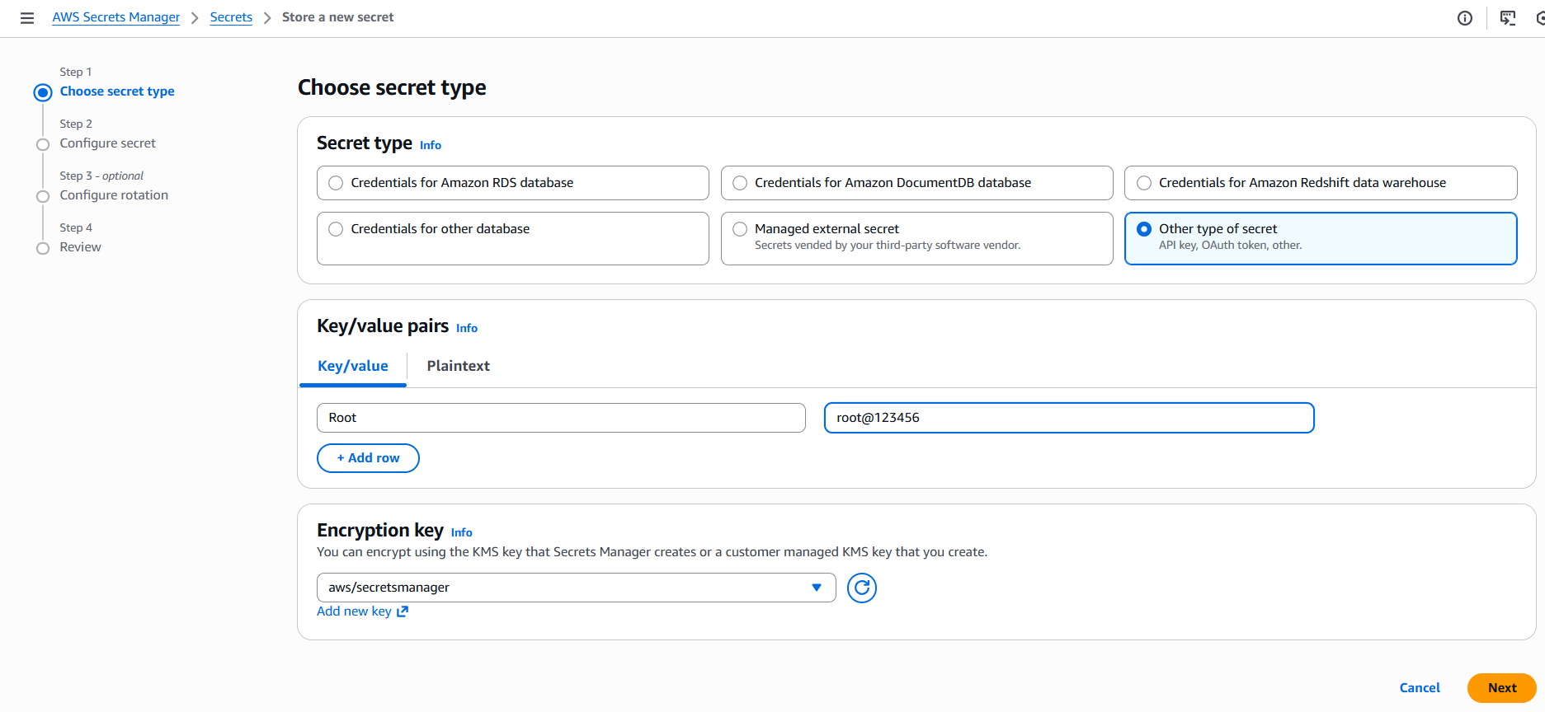
Step 3: Configure secret and provide the Secret Name and description.
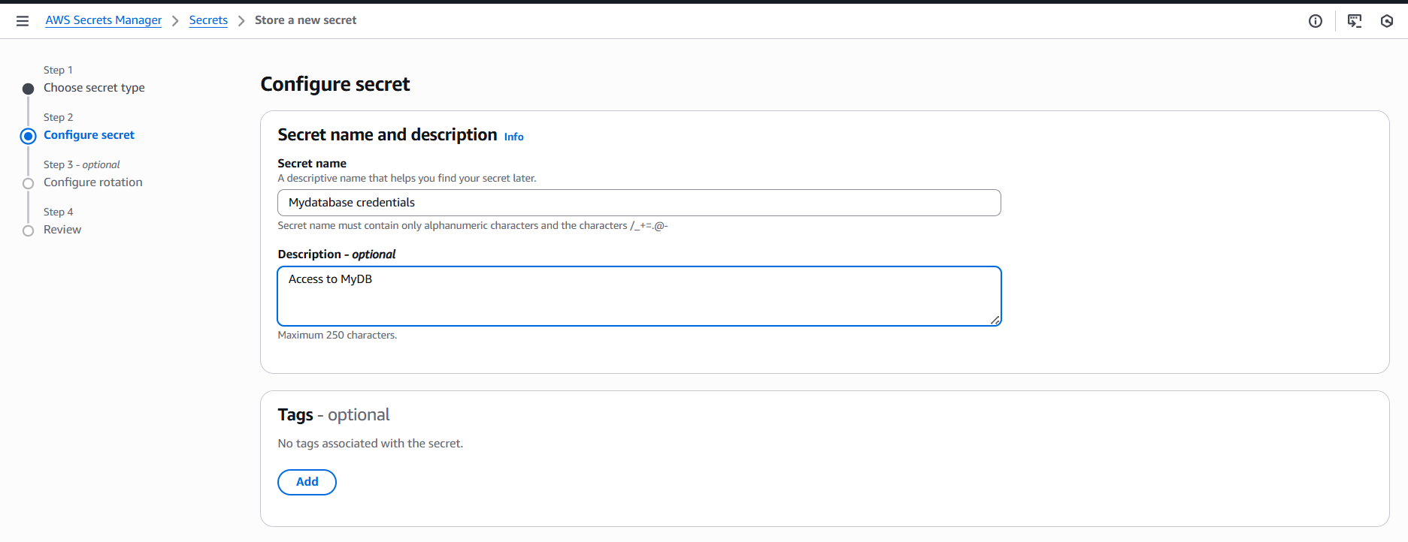

Step 4: Final review and store the credentials in the Secrets Manager.
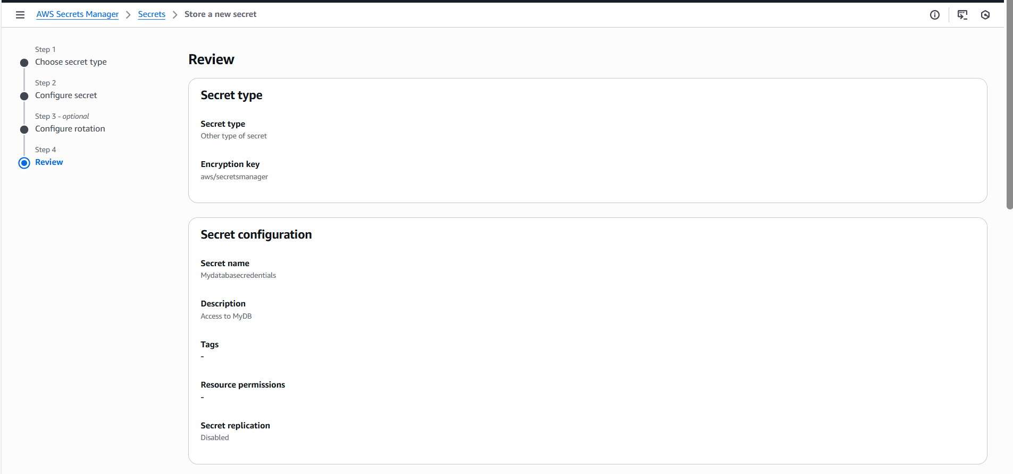

Step 5: The code is stored in AWS SM.
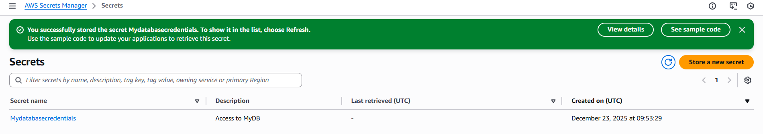

Step 6: If required to view the access credentials, then we need to click the Secrets and scroll down to “Retrieve secret value” and open.
- Successfully, we can view the credentials.
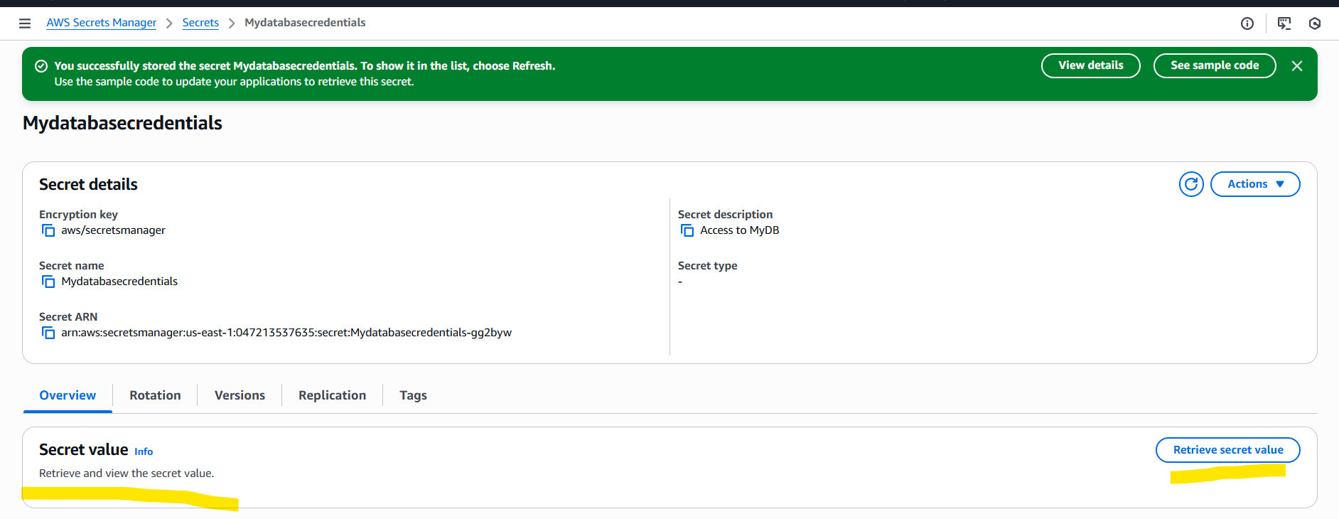

Conclusion:
Key Management service is really helpful when you want to keep your files secure without anyone viewing them or exposing your content to your company fellas.
How this is done is, by encrypting and decrypting the plain text using Symmetric and Asymmetric keys.

Secrets Manager is helpful to store the credentials or secrets. Instead of using GitHub, (. gitignore) or code, we can securely encrypt them and store in Secrets Manager in AWS.

